**Case Study**: **Grafana Dashboard for JMeter Performance Monitoring**

**Configuring JMeter to send performance metrics to InfluxDB.**

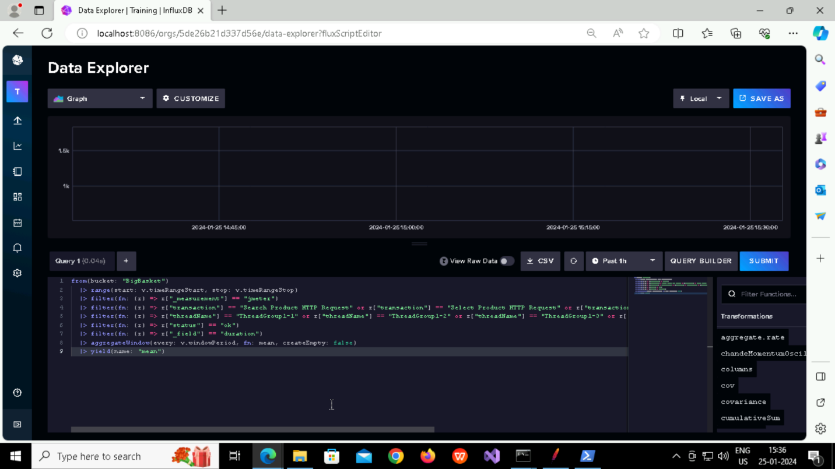

**Setting up Grafana and adding InfluxDB as a data source**

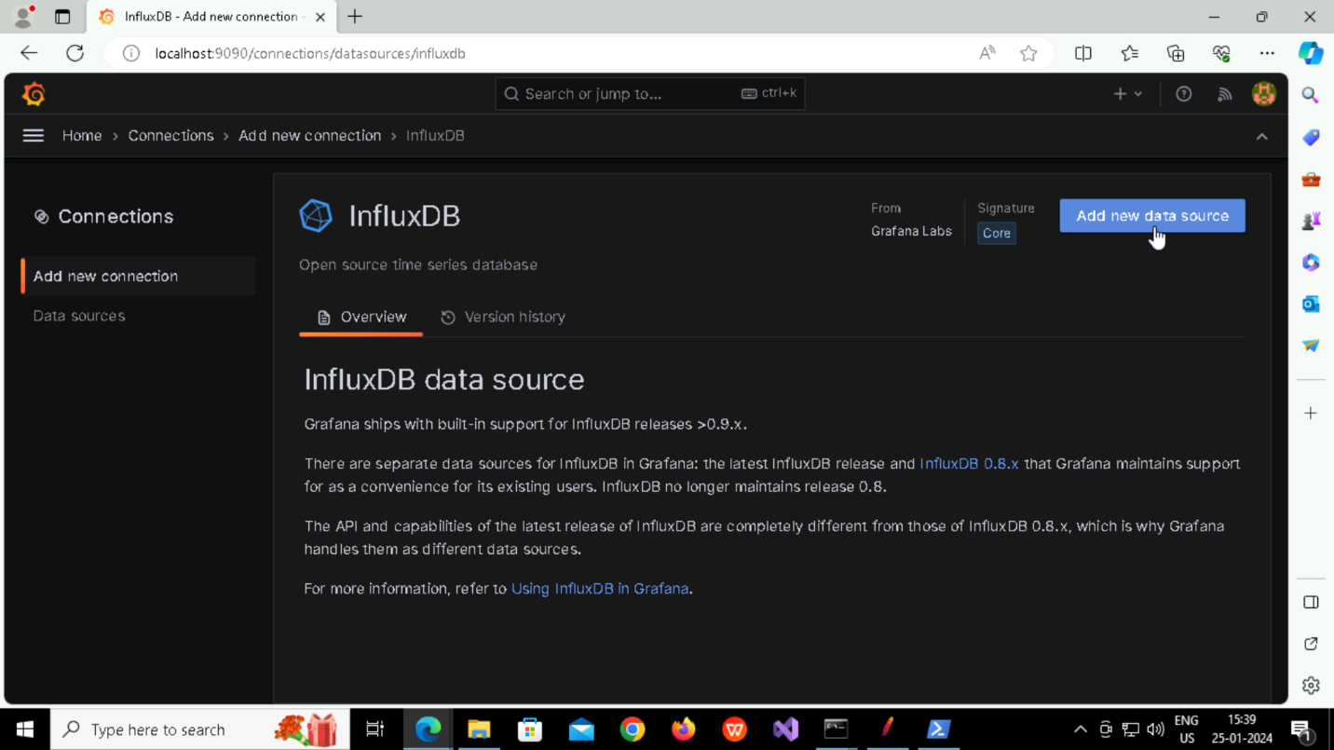

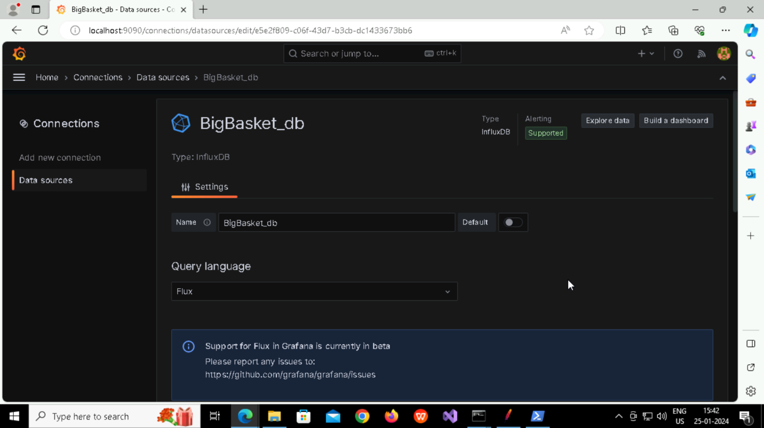

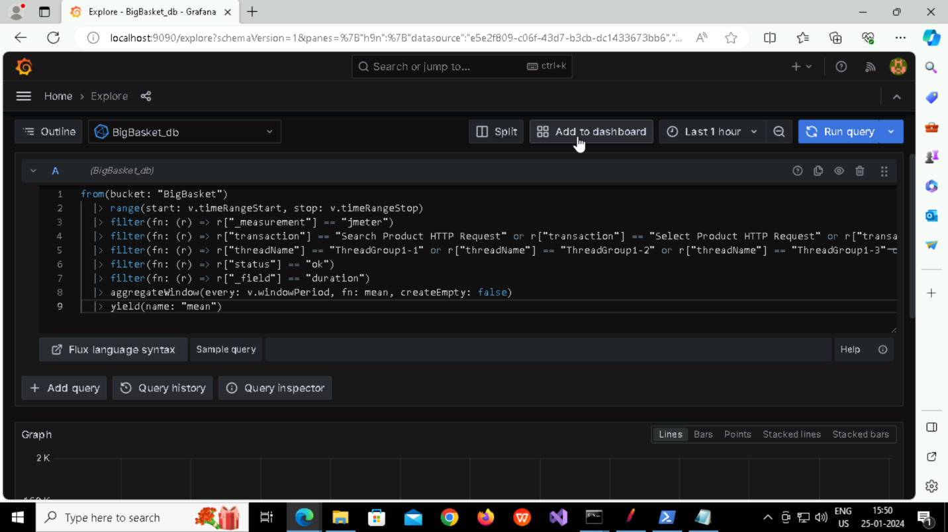

**Configuring panel to display the desired metric using InfluxDB queries.**

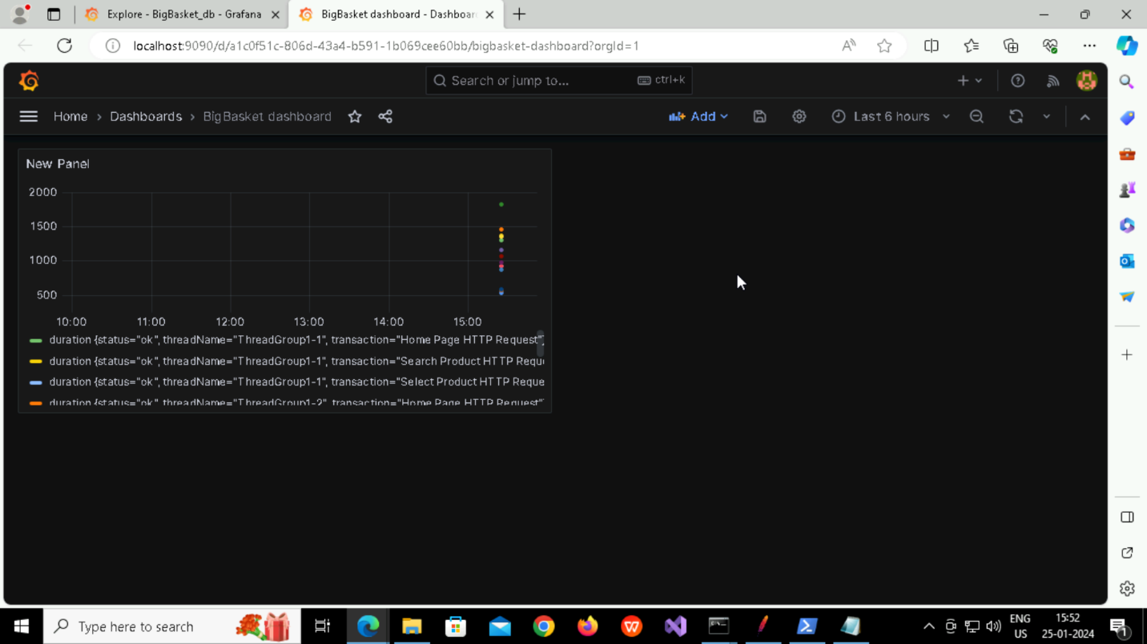

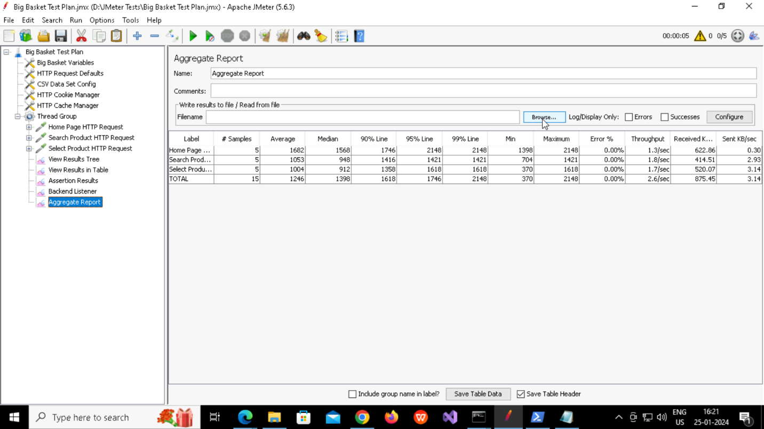

**Adding a CSV data source and linking to the panels for additional context.**



